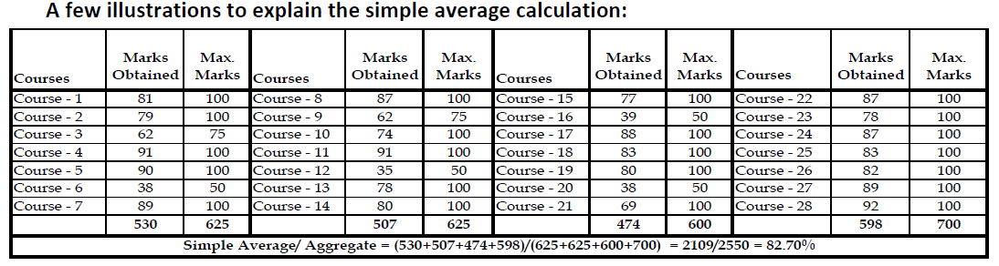

**Note:**

* Please use only the above method to calculate the simple average/ aggregate for each of your academic qualifications
* If your college follows a CGPA system, please ensure that the CGPA is calculated taking into account each and every course that you have undertaken in the curriculum, including optional or additional subjects (if any)
* If you have done your Diploma after X and have joined directly as a lateral entrant into 2nd year of BE/ B.Tech, please calculate the aggregate for all the 3 years of Diploma (including all languages/ optional subjects/ additional subjects undertaken during the 3 years) and capture the same separately. Compute the aggregate for Engineering from the 2nd year (3rd semester) onwards to the final semester; as applicable
* Please ensure that there is no intentional or unintentional misrepresentation of data since this shall lead to disqualification of the candidature or termination of employment, if made an offer.